RAD Approved Venue entry form RAV1 (2019)
An RAV2 form must be completed for each vocational graded candidate and an RAV3 form must be completed for graded candidates
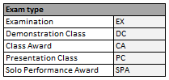
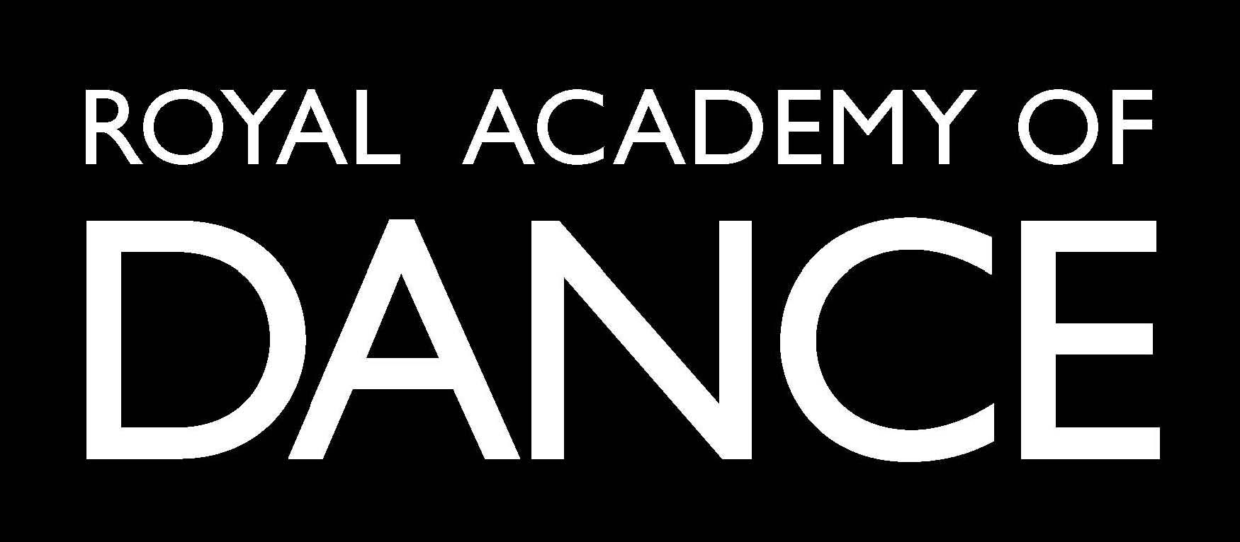
PO BOX 245,
Kings Cross,
NSW, 1340
T: (02) 9331 4111
E: exams@rad.org.au

Part A – Registered school information |  |  |  |  |  |  |  |  |  |  |  |  |  |  |  |  |  |  |  |  |  |  |  |  |  |  |  |  |  | Part E – Summary of candidates and fees
Name of School |  |  |  |  |  |  |  |  |  |  |  |  |  |  |  |  |  |  |  |  |  |  |  |  |  |  |  |  |  | Candidate ID | Given name | Family name | Member | Level e.g. IF | Exam type | Syllabus M/F | Fee | Office use
School ID
Email
Tel
Part B - Examination venue information
RAD Approved Venue
RAD Approved Venue ID (if known)
Part C - Registered teacher details
 | Membership ID |  |  |  |  |  | First name |  |  |  |  |  |  |  |  |  |  |  | Family name
Teacher 1
Teacher 2
Teacher 3
Teacher 4
Teacher 5
Teacher 6
Part D – Applicant details
Name of Applicant
Membership ID (if applicable)
Please select from the below:
Applicant |  |  |  |  |  | School principal |  |  |  |  |  |  |  |  |  |  |  |  |  |  |  |  |  |  |  |  |  |  |  | Total candidates (non-members): |  |  |  |  |  | Sub-total fees:
Teacher (select as per number above) |  |  |  |  |  |  |  |  |  | 1 |  |  | 2 |  |  | 3 |  |  |  | 4 |  |  |  | 5 |  |  | 6 |  |  | Total candidates: |  |  |  |  |  | Total fees:
Address for correspondence and delivery: |  |  |  |  |  |  |  |  |  |  |  |  |  |  |  |  |  |  |  |  |  |  |  |  |  |  |  |  |  | Part F – Signature of Applicant
Postcode |  |  |  |  |  |  |  |  |  |  |  | Tel
Email
Impossible dates for delivery
I am happy for a neighbour to receive my delivery |  |  |  |  |  |  |  |  |  |  |  |  |  |  |  |  | Yes |  |  |  |  |  |  |  | No |  |  |  |  | Name of Applicant Date

