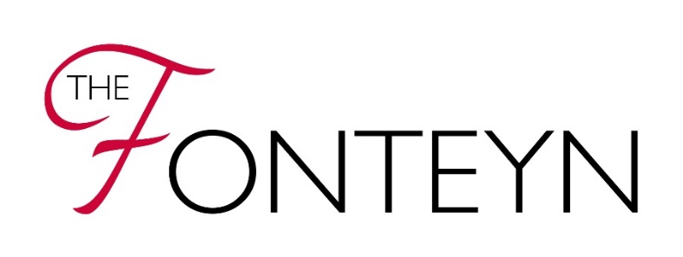
Your Online Stage

If the candidate is under 18 years, this form should be completed by a parent/guardian.
PART ONE: Register for the project

Name of candidate
Age of candidate
Nationality of candidate
Name of Teacher
Name of Coach (if different from teacher)
- I confirm that I meet the eligibility criteria for The Fonteyn competition.

PART TWO: Use and consent
The RAD will take all steps to ensure videos for this project are used solely for the purposes they are intended. If you become aware that any videos relating to this project are being used inappropriately, you should inform us immediately.

- I give permission for the submitted video to be stored on the RAD’s Dropbox folder for the purpose of this project.
- I agree to the candidate name and nationality being listed on the RAD Dropbox folder.
- I agree to the teacher’s name being listed on the RAD Dropbox folder and I have obtained their permission.
- I agree to allow my video to be saved by the RAD for archive purposes.
- I understand that other prospective candidates will be able to view my video for the purpose of this project.
- I understand that whilst RAD prohibits the sharing of the Dropbox link, I acknowledge that it is possible that the link may be shared with others outside of the project.
- I will not share the Dropbox link with non-eligible candidates and others.
- I understand that RAD will comply with relevant policies, including the Safeguarding Policy and Social Media and Digital Communications Policy, which can be accessed here.

Signature of candidate/parent/guardian* [delete as appropriate] *may be typed if you do not have a printer/scanner: | Print name of candidate/parent/guardian [delete as appropriate]:
Date:

RAD will store the videos on Dropbox for the period of the project, after which time, RAD will store the videos privately and securely for a further 3 months. To view how your data will be used and stored, please refer to our Privacy Policy.

