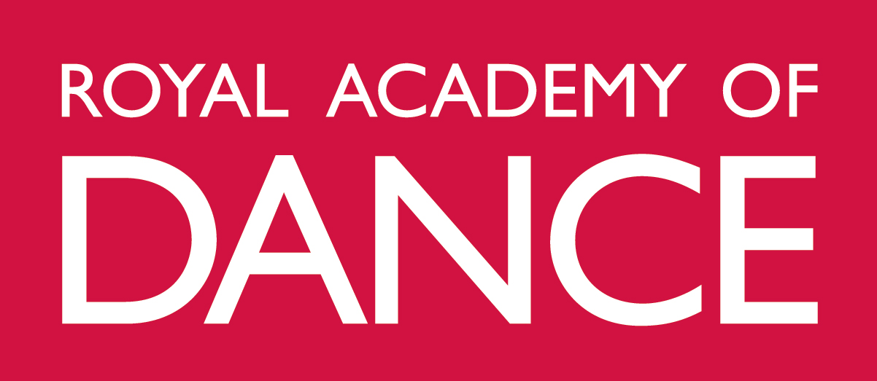
Awards Day 2021 - Frequently Asked Questions

Do I have to book a place to attend the virtual ceremony?
Yes, booking is essential in order to attend. You will find a link to book your place in the email invitation. This will also include the time of your ceremony.
Please note that there are limited spaces in each time slot and should we be oversubscribed you may be moved to another time within 2 hours of the time original slot.

When and how will I receive my invite? How do I respond to my invite?
You will be sent an email to the email address with which you registered with the RAD whilst on programme. The email invite will include a link allowing you to respond giving you three options: Attend virtually in 2021, Attend in person in 2022 or not Attend.
Email invites will be sent in April 2021. If you do not receive an invite in April please contact alumni@rad.org.uk
All graduates should respond to the email invite by June 1st 2021.

How much does it cost to attend?
Attendance to the virtual ceremony is free.

Is it possible to attend an Awards Day Ceremony in person?
There will be no in person ceremony in 2021. Should you wish to attend in person you will be able to attend in 2022.

If I do not wish to attend a virtual ceremony, can I defer my attendance to a future ceremony in person?
Those who do not wish to attend a virtual Awards Day in 2021 can choose to attend Awards Day 2022 in person. The details of this graduation and option to purchase guest tickets will be release in early 2022.

Can I attend both the virtual ceremony in 2021 and Awards Day in 2022?
No. You have a choice of attending the virtual ceremony in 2021 or the in-person graduation ceremony in 2022, but you cannot attend both. Details regarding the in-person 2022 ceremony will be provided in due course.

How long will the ceremony last?
The ceremony should last no longer than 90 minutes.

If I am unable to attend my virtual ceremony time slot, can I attend a different time slot?
Due to the large number of international attendees and scheduling of the online ceremonies, we are unable to move graduating students from one ceremony time slot to another.

How do I attend the virtual ceremony?
Instructions for attending the virtual ceremony will be sent to attendees in advance of the ceremony via e-mail.

Is there a dress code?
You should be dressed smartly for the event and if you would like to wear your National/Regional Dress we would be delighted for you to represent your country/region in this way. You are not required to wear formal academic dress for the ceremony, however, all students will also be able to purchase a mortarboard hat from supplies Ede & Ravenscroft to wear on the day and keep as a souvenir of the experience. A link to purchase a mortarboard will be sent to those choosing to attend the virtual ceremony.

Will there be a guest speaker/programme of events?
This year Dame Darcy Bussell will be the guest speaker. You will be sent a digital programme in advance of the day.

Will I have to speak to accept my award during the ceremony? Do I have to be on camera during the ceremony?
You will not have to speak to accept your award during the ceremony. Each student will have their name presented by their Programme Manager whilst they are visible on screen. You will need to have your camera on for this portion of the ceremony.
Are friends and family who do not reside with me, permitted to attend the ceremony online?
Students should be the only person visible whilst in the ceremony. However, the ceremony will be streamed live on a social media platform for friends and family to watch you graduate from any location. A link for this will be sent closer to the date.

Who can I contact if I have problems connecting to the virtual ceremony on the day?
Nearer the day we will send instructions about who to contact, should you have difficulties.

Will there be any photos or recordings of the ceremony that I can access?
The virtual ceremony will not be recorded.
Those who are resident in the UK will be able to attend a Photo Day at the RAD’s New Headquarters in late 2021. Here professional photographers Tempest will take a photo of graduates in graduation robes. The cost of the photo and graduation robes is to be covered by the graduate. There will be further a separate booking system for this released later in the year.

When will I receive my certificate?
Certificates for RAD Awards will be posted in the summer and should arrive in advance of the ceremony. Certificates from the University of Bath will be posted in the autumn and dependant on the University’s printing timetable.

