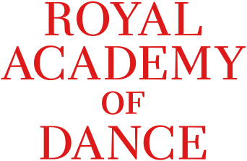

Photograph and filming/recording consent form

Australian Advanced 1 Bursary

The Royal Academy of Dance (RAD) does not allow photographs, video, audio (sound) recording or any other images of anyone to be taken without their consent, or consent of their parent/guardian/carer.

By signing this form, you agree to give the RAD your consent to be photographed / filmed by {name of person filming}. {Name of person filming} is filming on {date} at {location}, in order to complete a video for submission into the Australian Advanced 1 Bursary.

The RAD will be using the footage in the following ways:

- For internal/RAD purposes in judging the winner of the Australian Advanced 1 Bursary.
- As promotional material in RAD publications (print and digital)
- On the RAD website and social media channels
- To distribute to press and media outlets to use in their print/digital publications and on their social media channels to promote the Australian Advanced 1 Bursary, as requested.

By signing this form, the candidate and choreographer (if not the candidate themselves) will give the RAD consent to use the footage of you for the purposes listed above. The RAD will only keep and use the footage for as long as is appropriate for business purposes (this means, for as long as we need to have access to the video in order to operate as a company). In this instance this until completion of the Australian Advanced 1 Bursary and accompanying media by April 2023.

The candidate is free to withdraw consent at any time by sending an email to marketing@rad.org.au. Please note by withdrawing consent you will be disqualified from the Australian Advanced 1 Bursary Competition.

You do not need to specify a reason why you are withdrawing consent as well. If you do decide to withdraw your consent at a later time any pictures/videos/audio taken and uploaded will not be used in any future publications or on our websites, but may continue to appear in publications already (including hardcopy publication) in circulation or in cache until cleared.

Please tick the options below as appropriate.

For the candidate

- I confirm that I have consented to participate in this filming and any further filming or photographic opportunities as a result of my entry into the Australian Advanced 1 Bursary. I give consent for the RAD to use the images/footage/recording, as outlined in this form.

- I confirm that I am happy for the following information to be used about me, with the images/footage/audio
- Name
- Age
- Dance School

Signature of parent/guardian/carer as entrant is under 18 years:

________________________________________________Date: ___________________

